Project Utilization Report – Jama 4.2 – Report Setup

SQL Backend

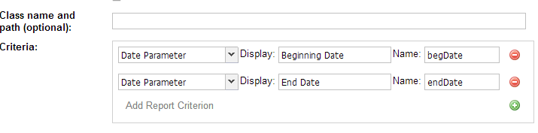

MySQL and Oracle Backends

